**General Information**

**SEASON DATES:**

October 23,2025 --- January 31, 2026

Price: Duck $45.00 Geese $45.00

**Legal wildlife during season:** Ducks including Mergansers, coots, and gallinules; including white (snow/blue, Ross) and dark geese (Canada, cackling, Brant, white fronted) and scaup.

**Bag limit:** The daily bag limit:

**Ducks:** including mergansers: 7 per day not to include more than: 2 redheads; 1 pintail; 2 canvasback; 2 scaup; 1 black-bellied whistling duck; and 7 mallards, no more than 2 of which may be female or Mexican ducks. Coots and gallinules: 25 per day, singly or in the aggregate.

**Geese:** 20 white geese (snow, including blue and Ross’ goose) per day and 5 dark geese (Canda, cackling, Brant and white-fronted) per day.

**Possession limit:** The possession limit of ducks including mergansers: 21 after opening day, only seven of which may be taken any one day, but no more than: 6 redheads; 6 female mallards or Mexican ducks; 3 pintails; 6 scaup; 6 canvasbacks; 3 black-bellied whistling ducks; Coots and gallinules: 75. Geese: 60 white geese (snow, including blue and Ross’ goose) and 15 dark geese (Canada, cackling, Brant and white-fronted).

**Shooting hours:** ½ hour before sunrise to sunset.

,

**Common Violations**

1. Shooting within ¼ mile (440 yards) of an occupied structure
2. Littering
3. Shooting across or from a roadway regularly used and maintained for public use.
4. Shooting before or after legal hunting hours.
5. Speeding on farm or other dirt roads (if not posted the maximum speed limit is 25 mph).
6. Hunting without a valid FMIR hunting license.
7. Not leaving one-fully feathered wing attached for game identification until you reach your residence.
8. Hunters are required to watch a onetime educational video on hunting on the FMIR, safety and game identification and pay a $5.00 fee for this: available at www.fortmojavetribalpolice.com

FORWARNED

1. **YOUR HUNTING PERMIT is invalid if you are found hunting in the closed portions of residential sections (12, 14 and 28) you will lose your hunting privileges for the remainder of the season and be subject to citation and seizure of hunting gear (See MAP for clarification).**
2. **Hunters found hunting in closed areas other than those listed above may lose their hunting privilege and will receive citations for applicable offenses.**

ALL SALES ARE FINAL

NO REFUNDS AND/OR EXCHANGES

**Fort Mojave Indian Reservation**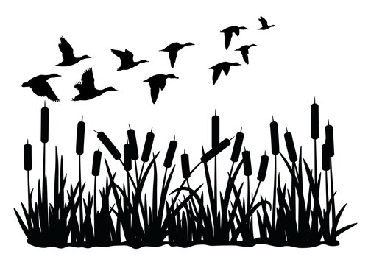

?';

2025-2026

**Waterfowl Hunting**

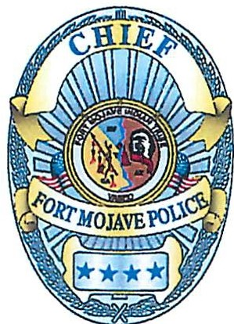

Oct 23, 2025, to Jan 31, 2026

You are required to have in your possession a Federal Migratory Waterfowl Stamp, to hunt waterfowl on the Fort Mojave Indian Reservation.

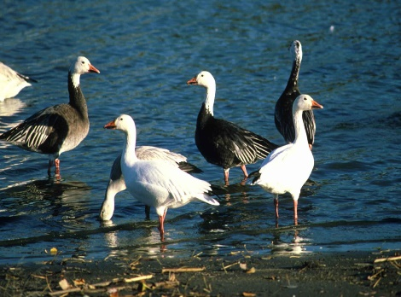

**Motor Vehicle Restriction:** No person may take migratory game birds from or by means, aid, or use of any motor vehicle, motor driven land conveyance, or aircraft of any kind.

**Watercraft Restrictions:** Migratory game birds may not be taken from or by any means of watercraft or other craft having a motor attached, or any sailboat, unless the motor has been completely shut off and/ or sails furled, and its progress from there has ceased. A watercraft under power may be used to retrieve dead or crippled birds but no shooting is permitted while the watercraft is underway. No person shall take migratory game birds by means or aid of any sailboat used for the purpose of or resulting in the concentrating, driving, or rallying, or stirring up of any migratory bird.

**Decoys, Calls and Baiting:** Migratory game birds may not be taken by the use or aid of live decoys, recorded or electronically amplified imitations of bird calls or sounds. It is illegal to take birds by the aid of baiting.

**Lawful taking device:** Waterfowl may be taken with a 10 gauge or smaller shotgun capable of holding not more than 3 shells using non-toxic shot only. Bow and arrow or crossbow.

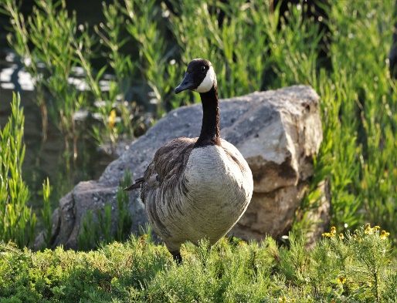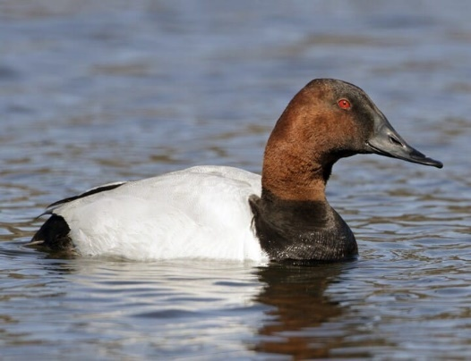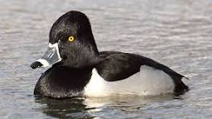

**Junior Hunters**

Junior hunters: fourteen years of age and younger receive a complimentary hunting license with proof of a completion of a hunter safety class (no exceptions).

Junior hunters must be accompanied by an adult who has a valid hunting permit. Junior hunters are allowed only half of the regular bag limit prescribed by the Fort Mojave Indian Tribe.

**Attention Hunters**

Areas are subject to closure without notice OBEY POSTED SIGNS many of the huntable sections are active agricultural areas, if a farm worker asks you to leave, please comply. Field areas are periodically sprayed with pesticides.

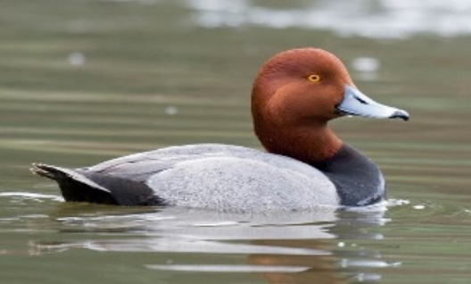

ALWAYS HUNT RESPONSIBLY