!General Information
Legal game: Mourning Dove, White-Winged Dove and Eurasian Collared-Dove.
SEASON DATES:
1st Season: Sept 1st- Sept 15th, 2026
2nd Season: Nov 13t^{h}, 2026 – Jan 10, 2027
For both the early and late seasons, the total daily bag limit of white wing and mourning doves is 15, with no more than 10 being white-winged dove. The total possession limit of white wing and mourning doves is 45, with no more than 30 being white-winged dove.

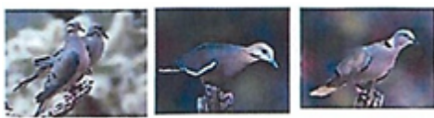
Mourning Dove Whitw-winged Dove Eurasion Dove

Eurasian Dove only: unlimited
With the purchase of an extended Eurasian Dove Permit you may hunt Eurasian Dove only, all year.
Extended Eurasian Dove Season:
Sept 1, 2026 - Aug 31, 2027
Eurasian daily bag and possession limit is unlimited.

,

DOVE: $45.00
EXTENDED EURASION DOVE
SEASON: $35.00
Animal Control Division

7500 Dike Rd, Mohave Volley, AZ 86440
•
Phone: 928-330.3000
Fox:9.28-330-3005

Common Violations

- Shooting within ¼ mile (440 yards) of an occupied structure
- Littering
- Shooting across a roadway regularly used and maintained for public use.
- Shooting before or after legal hunting hours.
- Speeding on farm or other dirt road (if not posted the maximum speed limit is 25 mph), hunting etiquette may dictate slower if other hunters are present.
- Hunting without a valid FMIR hunting license.
- Not leaving one-fully feathered wing attached for game identification while in the field.
- Hunters are required to watch once a year an educational video on hunting on the FMIR, safety and game identification and pay a $5.00 fee for this. This video can be viewed at www.fortmojavetribalpolice.com

FORWARNED

- YOUR HUNTING PERMIT is invalid if you are found hunting in the following closed portions of residential sections (12, 14 and 28) you will lose your hunting privileges for the remainder of the season and you will receive a citation, and your hunting gear may be seized (See MAP for clarification).

ALL SALES ARE FINAL
NO REFUNDS AND/OR EXCHANGES

Fort Mojave Indian Reservation

?';
Dove Season

Early Season:
Sept. 1st - Sept. 15th, 2026

Late Season:
Nov. 13, 2026, to Jan 10, 2027

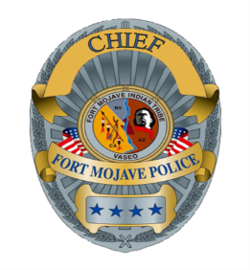
2026 - 2027

Fort Mojave Tribal Police Department

8494 South Highway 95, Mohave Valley
AZ 86440

Phone: 928-346-1521
Emergency: 911

Dove Hunting Rules &
Regulations

The Fort Mojave Indian Reservation is located along the Colorado River in the tri-state area of California, Nevada and Arizona. The largest area of land can be found in Arizona. You are required to follow the rules and regulations of the FMIT regarding hunting and all other applicable laws, rules and regulations. This permit is only valid within the FMIR.

When hunting dove on the FMIR you are required to have in your possession a valid FMIT issued hunting permit.

WEAPON: Dove may be taken by shotgun or bow and arrow. Shotguns must be plugged so that their total capacity of shotshells does not exceed three (3).

MOTOR VEHICLE: No person may take or harvest migratory game birds from or by means, aid or use of any motor vehicle, motor-driven land conveyance, or aircraft of any kind.

DECOYS, CALLS and BAITING: Dove may not be taken by the use or aid of live decoys. It is illegal to take migratory game birds by the aid of baiting or by knowingly hunting over a field or other area the hunter knows to have been baited.

Dove Rules & Regulations continued

One feathered wing must be left attached to all migratory game birds and Eurasian Collared Dove, until they reach their final destination.

Hunters are required to be ¼ mile (440 yards) away from any occupied residential structures when hunting.

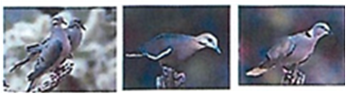

2026 - 2027
Fort Mojave Indian Reservation

Dove Season

Early Season:
Sept. 1st - Sept. 15th, 2026

Late Season:
Nov. 13, 2026, to Jan 10, 2027

Junior Hunters

Junior hunters: fourteen years of age and younger receive a complimentary hunting license with proof of completion of a hunter safety class (no exceptions).

Junior hunters must be accompanied by an adult who has a valid Dove hunting permit. Junior hunters are allowed only half of the regular bag limit prescribed by the Fort Mojave Indian Tribe.

Attention Hunters

Areas are subject to closure without notice OBEY POSTED SIGNS many of the huntable sections are active agricultural areas, if a farm worker asks you to leave, please comply. Field areas are periodically sprayed with pesticides.

HUNTERS FOUND HUNTING IN THE CLOSED PORTIONS OF SECTION(S):

- AZ- sections 35, 36, 2, 12, 14, 24, 9, 16, 28, 34, 4 and 10.
- NV – Avi Casino, Desert Springs Housing and Mojave Resort and Golf Course.
- CA – 9, 10, 12, 15,14, 13, 22, 23, 24, 27, 28, 29 and 35.
If you are found hunting in the above areas, your permit is invalid and you are subject to citations for trespassing, hunting without valid permit and your hunting equipment including firearms may be seized. DO NOT HUNT THESE AREAS

See available map (animal control office) for clarification of the closed areas that you can receive a citation of trespassing for, if found hunting within.

